Core Shadow (Form Shadow)

📘 Definition
# Source: AI Source: Provided by: [Data Path: Persons Table -> ID Column: 1, Name_En Column: Motasem Essam] -> From: [ChatGPT] on [5/2/2026]
A Core Shadow is the darkest part of a shadow on a 3D object. It appears on the surface of an object where light cannot reach directly, but it is not the same as the fully dark shadow on the ground.
It is also called the “form shadow” because it helps show the shape (form) of an object.

🌑 How Core Shadow forms
# Source: AI Source: Provided by: [Data Path: Persons Table -> ID Column: 1, Name_En Column: Motasem Essam] -> From: [ChatGPT] on [5/2/2026]
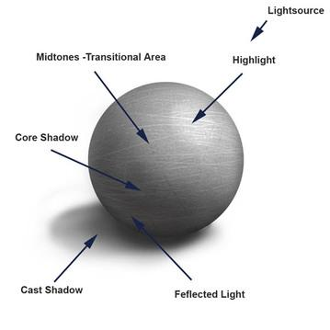
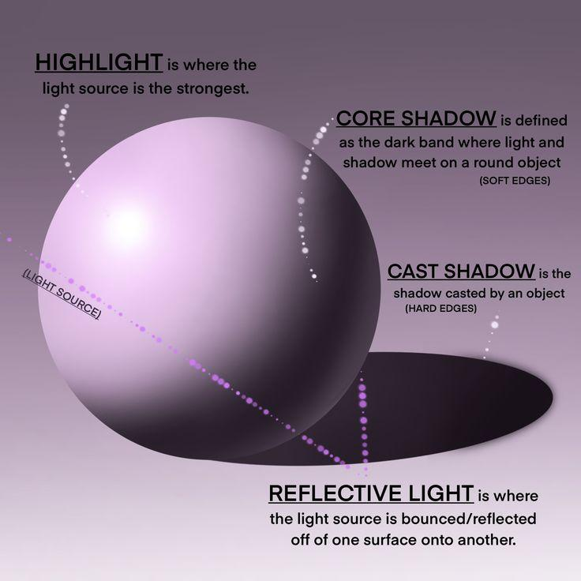
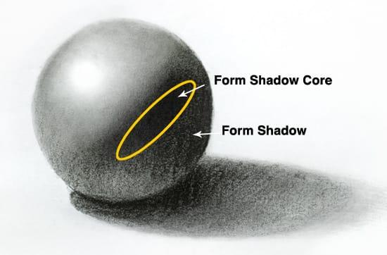
When light hits an object:
- ☀️ Light side → bright area
- ✨ Highlight → brightest spot
- 🌗 Core shadow → darkest area on the object itself
- 🌑 Cast shadow → shadow on the surface behind the object

🧠 Simple example
# Source: AI Source: Provided by: [Data Path: Persons Table -> ID Column: 1, Name_En Column: Motasem Essam] -> From: [ChatGPT] on [5/2/2026]
Think of a ball under a lamp:
- One side is bright
- The middle side (away from light) becomes dark → this is the core shadow
- The ground behind it has a separate shadow

🎮 Why core shadow is important
# Source: AI Source: Provided by: [Data Path: Persons Table -> ID Column: 1, Name_En Column: Motasem Essam] -> From: [ChatGPT] on [5/2/2026]
- Makes objects look 3D instead of flat
- Shows roundness and depth
- Used in realistic drawing, painting, and 3D graphics

⚙️ Key features
- 🌑 Darkest part on the object itself
- 🎯 Located away from the light source
- 🧩 Helps define the shape of the object
- 🎨 Essential for realistic shading

🚀 In short:
# Source: AI Source: Provided by: [Data Path: Persons Table -> ID Column: 1, Name_En Column: Motasem Essam] -> From: [ChatGPT] on [5/2/2026]
Core Shadow = the darkest area on an object’s surface where light cannot reach directly, helping show its 3D shape.

